NCI PROGRAMME LIFECYCLE MANAGEMENT (PLM)

Programme Retirement Form (PRF)

Version 1.0, P. Maguire 24th March 2022

Version 2.0 S. Hegarty 25th April 2022

Version 3.0 P. Maguire 3rd May 2022

Version 4.0 S. Hegarty 6th May 2022

1.0 Programme Lifecycle Management (PLM) Process
1.1 Aim
The PLM process seeks to ensure that new NCI academic programmes are aligned with the strategies of School(s) and of the College as a whole and are underpinned and supported by evidence of relevance and academic currency in the current/emerging market and learner/employer demand. The PLM process aims to support the effectiveness of decision-making about programmes by providing transparent, systematic approval and reflection points across the entire programme lifecycle. The process is structured, yet nimble, and will consider all programme opportunities in an informed and equitable manner.
This will help NCI to continue to maintain and invest in a sustainable and attractive portfolio of programmes and support opportunities for growth.
1.2 Programme Lifecycle Management Structure
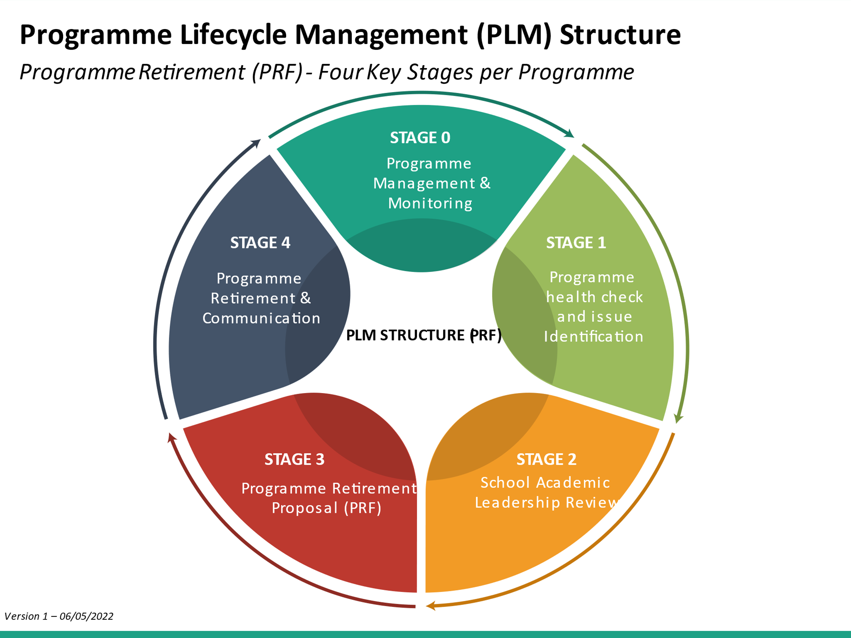
The Executive Sub-Group (ESG) will assume the responsibilities of a Programme Lifecycle Management committee, as set out in Stage 1 of the above process workflow diagram.
The ESG will make recommendations to the Executive Group (EG) and the Academic Council (AC) on programme viability, sustainability and quality, based on four key domains:
- Strategic Value and contribution to NCI
- Stakeholder demand and/or market opportunity
- Contribution margin
- Business contribution (for example, utilisation of strategic/academic/operational assets; building organisational capacity and capability; building competitive advantage or brand specialties)

The Executive and Academic Council will provide regular updates to NCI’s Governing Body on the College’s existing and developing programme portfolio, in the context of the NCI Strategic Plan and its constituent elements.
1.3 Programme Retirement Form (PRF) Form and Approval process
Programme Directors are asked to complete a PRF form for proposals to formally retire a programme from the NCI portfolio. The Programme Lifecycle Management (PLM) Executive Sub-Group (ESG), chaired by the Vice-President, will consider all PRF forms within two weeks of submission to the Quality and Institutional Effectiveness Office (QIE), to ensure all proposals are considered in a timely manner.
This form should be used in the following circumstances:
- Suspend recruitment to a programme for a fixed period (programme suspension);
- Close a programme and cease recruitment permanently where there are existing students on the programme (programme withdrawal); and/or
- close a programme that does not have any existing students and where the School has reached a decision to no longer offer the programme (programme closure).
The PRF Form should be counter-signed by the Dean/Director of CELL/Director of ELI (as appropriate), to confirm support for the proposal at a School/Centre level. Programme proposers will be invited to attend the respective PLM ESG discussion to discuss their proposal. The role of the PLM ESG is to reach a decision on whether the programme proposal is recommended for suspension/withdrawal/closure.

2.0 Programme Retirement Form (PRF) Form

2.1 Proposer
Proposer
Name
School/Centre
Email address
Contact tel:

2.2 Programme
Programme information
Programme Award and Title:
Embedded Awards if the embedded award is exit-only (i.e. no direct student recruitment into the programme)- please state:
Micro-credentials
Programme Code/s (QIE to populate)
Location of delivery

2.3 Course of Action
Please indicate the course of action you are seeking approval for:
☐ | Programme Suspension: | Please indicate the proposed period of suspension e.g. 2020-21
☐ | Programme Withdrawal and date from when this applies:  To cease recruitment permanently where there are existing students on the programme
☐ | Programme Closure:  Close a programme that does not have any existing students

2.2 Essential Programme Information
Programme title & Stream
What are the current progression routes for students on this programme?
What is the expected date of completion of the final Cohort?(QIE to populate)
How many current students are on the programme (if applicable provide details of registered students by stage)?
Are there any students who have interrupted and who will complete later? If the expected completion date is known, please provide details.
Are there applicants to which offers have been made? Please provide details of this
Are there any arrangements with Third Parties such as arrangements with PRSBs, Awarding Bodies, QA Bodies, Collaborative Provisions or Articulation Agreements? Please provide details of this (QIE to populate)

(QIE to populate)
Award Class | Programme Title(s) | NFQ Level | Total  ECTS | FT/PT/  both | Domestic/EU/non-EU/all
Major
(Master/
PGDip/
Bachelor/
Ordinary degree/HDip)
Minor
(e.g. Higher Certificate, Diploma)

Special Purpose or Supplementary award (e.g. professional certificate/
professional
diploma)
Micro-credential

2.3 Strategic Case for approval
Please complete section 1-6 below, limiting each section to approximately 300 words. The Programme Lifecycle Management ESG committee will discuss the information provided with the named Programme Proposer.
The committee will make a recommendation to the Executive Group (EG) and Academic Council (AC) to retire the programme by recommending suspension, withdrawal, or closure, in line with NCI’s Quality Assurance handbook (Section 3.9.6) and with QQI withdrawal requirements (Section 12).

- Rationale & Strategic case
What is the rationale for the request to suspend/withdraw/close this programme? E.g. changes in patterns of demand from prospective students, changes in staffing, a strategic realignment of the portfolio, major organisational change.
How does the programme's suspension/withdrawal/closure fit with the school/centre’s ongoing strategic aims and plans?

- Impact
What impact will the suspension/withdrawal/closure of the programme have on the school and institutional academic portfolio?

- Alternative programmes (withdrawal/closure programmes only)?
In the case of programme withdrawal/closure are there plans for a replacement programme or other changes to the School’s portfolio? If so, please provide details.

- Anticipated implications
Use this section to outline anticipated implications such as:
- Is the programme being recruited for currently? What are the implications for applicants? Please include provisions up to award stage.
- Resource Implications:
- Existing Human resources: existing NCI faculty and/or associate faculty and existing NCI professional services
- Existing Physical Facilities/ IT resources/Library and so on.
- Does the proposed programme suspension/withdrawal/closure have any implications for other programmes or modules?
- Progression implications either progressing to or from another programme

- Internal and External Discussion and Agreement
Please provide details of the following.
  - Internal: Has this been discussed with the school/centre concerned?
  - External Discussions: Has this been discussed with any third parties such as PRSBs, Articulation agreements etc.
Internal Discussions:
☐ Admissions
☐ Marketing/Student Recruitment
☐ Central timetabling
☐ Other
Please include any comments below;

External Discussions:
☐ PRSBs
☐ Articulation Agreements
☐ Other
Please include any comments below;

ADDITIONAL INFORMATION
Please add any further information to inform the PLM SG decisions (no more than 500 words please).

APPROVAL TO SUBMIT TO PLM ESG
Once completed, this PRF should be emailed to: QIE@NCI.ie
School/CELL approval for submission granted by: | Submitted to QIE by:
 | Date submitted to QIE:

This will normally be the existing Programme Director. Where this is not the case, the Dean of the School or Director of CELL will be named as the Proposer.
Please note that only Faculty members can retire a programme.
For further information, please see: NFQ (qqi.ie)
A major award is an award that recognises the learner’s achievement of a broad range of programme-level learning outcomes, through the successful completion of a programme of study that a learner can use for a range of purposes. These outcomes may be at NFQ level 10 (doctoral award); 9 (Master’s/PGDip award); 8 (Bachelor’s degree or Higher Diploma award); 7 (Ordinary degree award).
A Minor Award is linked to a Major Award. Through the successful completion of a minor award, the learner has achieved some of the programme learning outcomes of the linked Major Award, and there will always be a progression opportunity from a minor to a major award e.g. The learner achieves a Diploma at NFQ level 7, which is a minor award, from which they can progress to a programme that leads to a Bachelor’s degree.
A Special Purpose Award recognises learners’ achievement of a specific and relatively narrow set of programme learning outcomes. There is no requirement for a progression pathway to a minor or major award. A Supplementary Award exists to recognise learners’ achievement of a set of learning outcomes that supplement, or are additional to, a Major Award.
QQI has not yet formally designated Micro-Credential as an award class of its own. For the purposes of validation, in April 2021, QQI defined a micro-credential as a programme with an ECTS (learner effort hours) range of 5-30 credits and which leads to a Special Purpose Award at NFQ levels 6-9. It is not yet clear whether learners with multiple, small micro-credentials can “trade-in” these credentials if they wish to receive a minor award from a Higher Education Institution (e.g. three MC’s worth 10-ECTS each at Level 9 = 30-ECTS postgraduate certificate (minor award with progression pathway to a PG Diploma and Master’s award).

