# NCI PROGRAMME LIFECYCLE MANAGEMENT (PLM)

# Programme Opportunity Proposal (POP) Version 3.7

## 1.0 Programme Lifecycle Management (PLM) Process

# 1.1 Aim

The PLM process seeks to ensure that new NCI academic programmes are aligned with the strategies of School(s) and of the College as a whole and are underpinned and supported by evidence of relevance and academic currency in the current/emerging market and learner/employer demand.  The PLM process aims to support the effectiveness of decision-making about programmes by providing transparent, systematic approval and reflection points across the entire programme lifecycle. The process is structured, yet nimble, and will consider all programme opportunities in an informed and equitable manner.

This will help NCI to continue to maintain and invest in a sustainable and attractive portfolio of programmes and support opportunities for growth.

# 1.2 Programme Lifecycle Management Structure

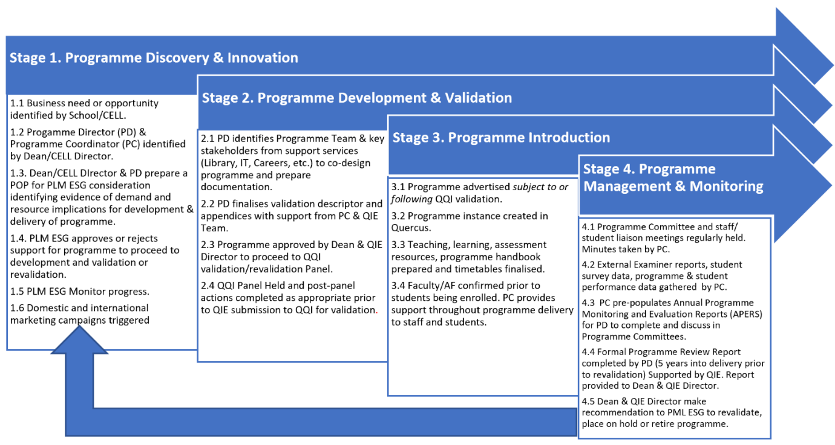

The Executive Sub-Group (ESG) will assume the responsibilities of a Programme Lifecycle Management committee, as set out in Stage 1 of the above process workflow diagram.

The ESG will make recommendations to the Executive Team (ET) and the Academic Council (AC) on programme viability, sustainability and quality, based on four key domains:

1. Strategic Value and contribution to NCI
2. Stakeholder demand and/or market opportunity
3. Contribution margin
4. Business contribution (for example, utilisation of strategic/academic/operational assets; building organisational capacity and capability; building competitive advantage or brand specialties)

The Executive Team and Academic Council will provide regular updates to NCI’s Governing Body on the College’s existing and developing programme portfolio, in the context of the NCI Strategic Plan and its constituent elements.

**1.3 Programme Opportunity Proposal (POP) Form and Approval process**

Programme Proposers must complete a POP form for all new programme opportunities for consideration by the NCI Programme Lifecycle Management (PLM) Executive Sub-Group (ESG). Chaired by the Vice-President, the PLM Executive Sub-Group will consider all POP forms within two weeks of submission to the Quality and Institutional Effectiveness Office (QIE), to ensure all opportunities are considered in a timely manner.

The POP Form should be counter-signed by the Dean/Director of CELL/Director of ELI (as appropriate), to confirm support for the proposal at a School/Centre level. Programme proposers will be invited to attend the respective PLM ESG discussion to discuss their proposal. The role of the PLM ESG is to reach a decision on whether to recommend that the programme proposal advances for further development and application to QQI for validation.

It is important to clarify that the POP form does not require details about the academic structure of the proposed programme (for example, the programme learning outcomes or the curriculum structure). This information will be required at the subsequent stages of the PLM process. The POP form requires the programme proposer to present the key strategic relevance and benefits, and the anticipated resource implications of the proposed programme(s), so that a “green light” can be given for further development of programme structure and content.

## 1.0 Programme Opportunity Proposal (POP) Form

# 1.1 Programme Proposer

|  |  |
| --- | --- |
| **Programme Proposer** | |
| **Name[1]** |  |
| **School/Centre** |  |
| **Email address** |  |
| **Contact tel:** |  |

# 1.2 Essential Programme Information

Please include the most up to date information that you have (final details may not yet be available).

|  |  |
| --- | --- |
| **Proposed programme title and award** | e.g.  BA(Hons)/BSc(Hons)/MA/MSc in.....  Diploma/Certificate in... |
| **Proposed first intake date** |  |
| **Subject/Subject area in NCI and cognate programmes\***  **\*include name(s) of existing cognate NCI programmes in this subject, where relevant.** |  |
| **Indicative Module Titles** |  |

|  |  |  |  |  |  |  |  |  |
| --- | --- | --- | --- | --- | --- | --- | --- | --- |
| **Award Class[2]** | **Programme Title(s)** | **Embedded Award (Stand-Alone Recruitment)**  **Y/N** | **Exit Award Y/N** | **NFQ Level** | **Total**  **ECTS** | **FT/PT/** **both** | **Domestic/EU/non-EU/all** | **Delivery modes**  **1.On-campus**  **2.Blended**  **3.Fully online[3]** |
| Major[4]  (Master/ PGDip/ Bachelor/ Ordinary degree/HDip) |  |  |  |  |  |  |  |  |
| Minor[5]  (e.g. Higher Certificate, Diploma) |  |  |  |  |  |  |  |  |
| Special Purpose or Supplementary award[6] |  |  |  |  |  |  |  |  |
| Micro-credential[7] |  |  |  |  |  |  |  |  |

# 1.3 Strategic Case for approval

Please complete section 1-5 below, limiting each section to approximately 300 words. The Programme Lifecycle Management ESG committee will discuss the information provided with the named Programme Proposer.

The committee will make a recommendation to the Executive and to Academic Council (AC) to approve provide a “green light” for the programme proposer and their team to fully develop the business and academic case for the new programme, in line with QQI programme validation requirements.

The Quality and Institutional Effectiveness Office (QIE) will support the named Programme proposer/team in their work.

|  |
| --- |
| 1. **Rationale**   **Rationale for the programme(s): why is this programme a promising idea for NCI? what are the aims and primary objectives that it seeks to fulfil?** |
|  |

|  |
| --- |
| 1. **Strategic Fit**   **How does this programme(s) align with the current Strategic Plan of the School/unit and with NCI’s overall Academic Strategy and Strategic Plan[8]?** |
|  |

|  |
| --- |
| 1. **Target Learners and business/industry/public sector need**   *Use this section to describe who this programme is for, giving some information on the anticipated short (0-3 years) and medium term (3-5 years)* ***size of the learner cohort and recruitment markets in Ireland/internationally.*** *Please outline the business and/or industry need for such a programme (articulated by employers/business/industry/relevant Irish Government/EU/OECD departments, state agencies or taskforces).* |
|  |

|  |
| --- |
| 1. **Projected Enrolment**   Use this section to describe the projected enrolment for the programme over the first five years. Provide estimates for both EU and Non-EU students (where applicable) for each year, ensuring to outline the rationale for these projections. |
| |  |  |  |  |  |  |  |  |  |  |  | | --- | --- | --- | --- | --- | --- | --- | --- | --- | --- | --- | |  | Year 1 (20xx) | | Year 2 (20xx) | | Year 3 (20xx) | | Year 4 (20xx) | | Year 5 (20xx) | | | **EU** | **Non-Eu** | **EU** | **Non-Eu** | **EU** | **Non-Eu** | **EU** | **Non-Eu** | **EU** | **Non-Eu** | | Minimum |  |  |  |  |  |  |  |  |  |  | | Maximum |  |  |  |  |  |  |  |  |  |  | |

|  |
| --- |
| 1. **Proposed Course Fee**   Use this section to describe the proposed course fee for the programme. Include the fee structure for both EU and Non-EU students, and justify the proposed rates based on benchmarking, programme costs, and market demand. |
| |  |  | | --- | --- | |  | Proposed Course Fee | | EU |  | | Non-EU |  |   **Rationale:** |

|  |
| --- |
| 1. **Details and rationale of any additional arrangements for the programme (ERASMUS, Third party, PRSB, awarding bodies and QA bodies), collaborative provisions or articulation agreements?**   *Use this section to describe if applicable, an Erasmus component in the programme. Additionally, detail any optional arrangements with third parties (such as PRSBs, awarding bodies, and QA bodies), collaborative provisions and articulation agreements. Include the rationale and ensure relevant stakeholders have been consulted before submitting this form* |
|  |

|  |
| --- |
| 1. **Rationale for proposed delivery mode(s)**   *Use this section to describe your rationale for the proposed delivery mode(s) for the programme. Where applicable, please clearly articulate the rationale for fully online programme design, assessment and delivery, paying particular attention to the rationale for proposed asynchronous assessment strategies. Please ensure that you have consulted with the Digital Design Learning team in CELL, before submitting this POP form.* |
|  |

|  |
| --- |
| 1. **Comparable national & international programmes**   *Use this section to outline comparable national & international programmes. Please Include some or all of the following information:*   1. *Programme title & NFQ level equivalency* 2. *Higher Education Institution delivering the programme (include country & any relevant rankings/accreditations of the HEI)* 3. *Length of programme (Include number of intakes per year) & ECTS credits/equivalent* 4. *What are the major similarities/differences with your proposed new programme (target learners of the programme, modules, delivery mode, industry project/placement opportunities etc.)?* 5. *Average enrolment numbers per year.* |
|  |

|  |
| --- |
| 1. **Anticipated new resource requirements**   *Use this section to outline anticipated new resource requirements:*   1. *New human resources: new NCI faculty and/or associate faculty and new NCI professional services (please provide the FTE required, even if estimated).* 2. *New Physical Facilities/ IT resources/Library and so on.*   *Please provide as much information as you can, however, note that the PLM committee will not expect to see full details of additional resources at this stage.* |
|  |

|  |
| --- |
| 1. **Anticipated implications for existing resources**   *Use this section to outline anticipated implications for:*   1. *Existing Human resources: existing NCI faculty and/or associate faculty and existing NCI professional services* 2. *Existing Physical Facilities/ IT resources/Library and so on.*   *Please provide as much information as you can, however, note that the PLM committee will not expect to see full details of the impact on existing resources at this stage.* |
|  |

|  |  |  |
| --- | --- | --- |
| 1. **Internal/External Consultation**    1. *Please tick all Internal Departments consulted in the programme proposal and any comments received in relation to the development of the programme.*    2. *Please list any additional external sources identified and consulted with in the development of the programme.* | | |
| **Internal Source (Mandatory)** | **Tick** | **Comments Received** |
| Teaching Enhancement & Digital Learning Design |  |  |
| Admissions |  |  |
| Exams |  |  |
| Student Support and Welfare |  |  |
| Finance |  |  |
| IT |  |  |
| Academic Operations |  |  |
| Marketing |  |  |
| International |  |  |
| Careers |  |  |
| Other (Please List): |  |  |
| **External Source (List External Sources if any were consulted)** |  |  |
|  |  |  |

**ADDITIONAL INFORMATION**

Please add any further information relevant to the proposal (no more than 500 words please).

**APPROVAL TO SUBMIT TO PLM-ESG**

The programme proposer is required to confirm that Dean of School, or Director CELL, is required to confirm support for the Programme Opportunity Proposal and that relevant professional service units have been made aware of the potential new programme.

Once completed, this POP should be emailed to: [QIE@NCI.ie](mailto:QIE@NCI.ie)

|  |  |
| --- | --- |
| I confirm that initial discussions have taken place within the School/CELL/across Schools (where relevant) and that relevant colleagues listed in Section 11 of this form have been made aware of the programme proposal. | |
| Programme Proposer (insert signature): | Please print name: |
| Date: |
| I confirm my support for this new programme proposal. | |
| Dean of School/Director of CELL (insert signature): | Please print name: |
| Date: |

1. Please note that only Faculty members can propose a new programme leading to a QQI award.
2. For further information, please see: [NFQ (qqi.ie)](https://nfq.qqi.ie/index.html)
3. If Online is selected, please indicate whether the programme will be designed for Synchronous delivery and assessment (Synch), Asynchronous delivery and Assessment (Asynch), or a mixture of both. Please refer to NCI’s QA Guidelines ([Chapter 13 on Technology-Mediated programmes](https://www.ncirl.ie/Portals/0/QA/Handbook/NCIQAH-13_Procedures%20and%20Guidelines%20for%20Online%20and%20Blended%20Learning.pdf?ver=2022-10-26-120416-390&timestamp=1666782501773)), for further guidance, or contact the Digitial Design learning team in CELL.
4. A major award is an award that recognises the learner’s achievement of a broad range of programme-level learning outcomes, through the successful completion of a programme of study that a learner can use for a range of purposes. These outcomes may be at NFQ level 10 (doctoral award); 9 (Master’s/PGDip award); 8 (Bachelor’s degree or Higher Diploma award); 7 (Ordinary degree award).
5. A Minor Award is linked to a Major Award. Through the successful completion of a minor award, the learner has achieved some of the programme learning outcomes of the linked Major Award, and there will always be a progression opportunity from a minor to a major award e.g. The learner achieves a Diploma at NFQ level 7, which is a minor award, from which they can progress to a programme that leads to a Bachelor’s degree.
6. A Special Purpose Award recognises learners’ achievement of a specific and relatively narrow set of programme learning outcomes. There is no requirement for a progression pathway to a minor or major award. A Supplementary Award exists to recognise learners’ achievement of a set of learning outcomes that supplement, or are additional to, a Major Award.
7. QQI has not yet formally designated Micro-Credential (MC) as an award class of its own. For the purposes of validation, in April 2021, QQI defined a micro-credential as a programme with an ECTS (learner effort hours) range of 5-30 credits and which leads to a Special Purpose Award at NFQ levels 6-9. There are three routes to validation. Route 1) for a new micro-credential programme that is not embedded/has no direct link to a minor or major award, QQI provides a specific validation process (QIE office will provide details). This validation is for 3-years maximum duration. Route 2) to validate one or more modules, between 5-30-ECTS, as MCs within a new, major award (as part of the new major award validation e.g. a new MA/MSc/PGDip), the standard new programme validation procedures apply. In this case, the small award(s) is validated as a Special Purpose Award, with 5 years’ validation, but NCI can choose to market the award as a micro-credential if we wish. 3) To retrospectively seek validation for new MC programme(s) of between 5-30 ECTS within an ***existing*** larger, validated award, then Route 1 can apply – we can use the specific MC validation process, but this is limited to a validation period of three years.
8. Proposals for new programmes should ensure broad alignment with the goals and actions of the NCI’s Strategic Plan which was published in November 2022.